**CAPTURE THE FLAG (CTF) MR ROBOT BREAKDOWN**

**Introduction**

In this presentation, I will display the steps that I used to capture all the flags presence in Mr. Robot Vulnerable Box. Mr. Robot Vuln hub is a vulnerable server which can be used to exercise penetration testing on a server.

**Requirement and Tools**

These are the requirements and tools used.

1. Presence of Virtual Box (preferred Oracle).
2. Kali Linux machine and Mr. Robot Vulnerable machine. Mr Robot vulnHub found here <https://www.vulnhub.com/entry/mr-robot-1,151/>
3. Nmap
4. Nikto
5. Burp Suite
6. Hydra
7. wpscan
8. netcat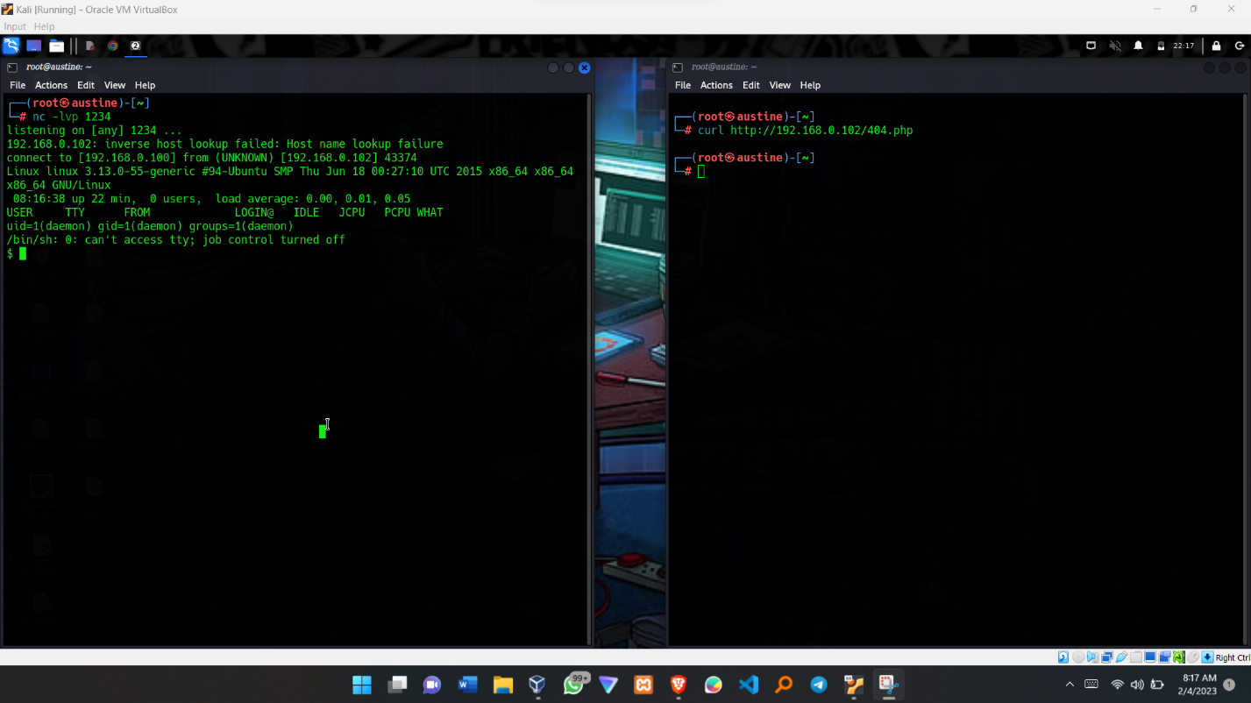
9. Reverse shell

**NB: Tools 3 – 7 already come preinstalled in Kali Linux. However, incase your using other Linux distributions you can install them.**

**PROCEDURE**

**Step 1 ;** By Using Nmap, the command aims at discovering the devices connected to your network. Command: **nmap -sS 192.168.0.0/24** From the results, the vulnerable machines runs with an ip of 192.168.0.102

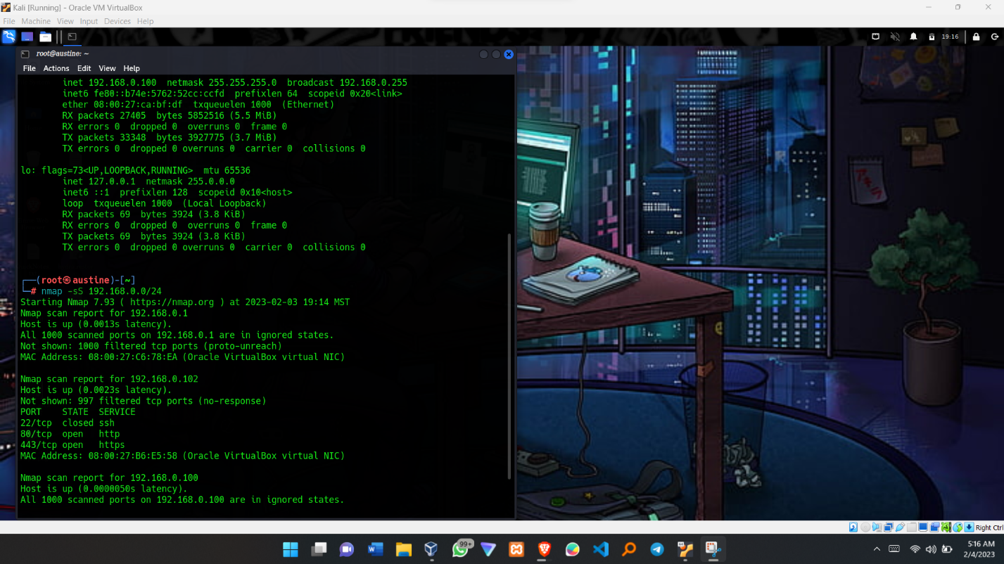

**Step 2;** Ping the Vuln Machines and open it in browser to confirm it runs successfully

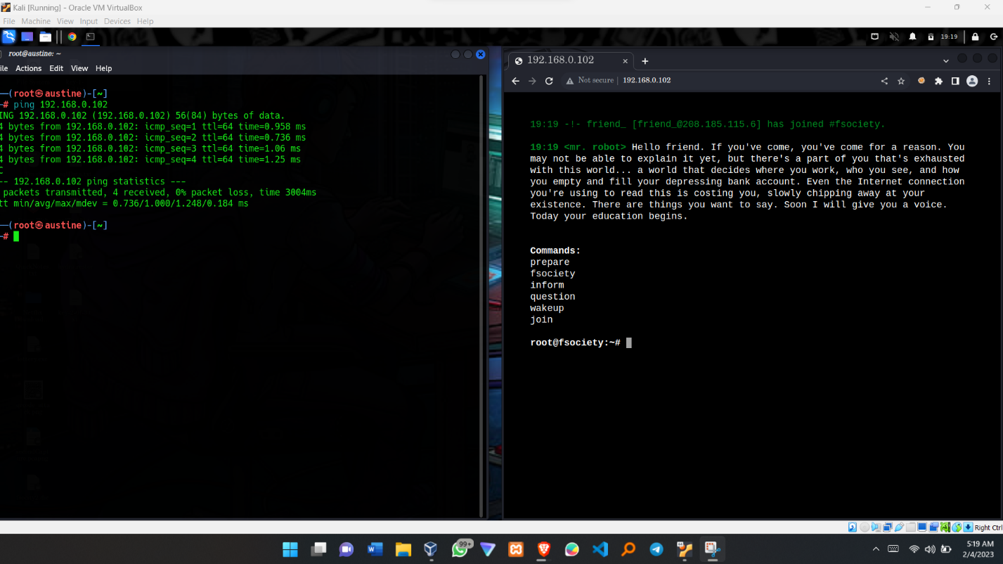

**Step 3:** Using Nikto to scan the Vulnerable machine. Command: **nikto -h 192.168.0.102**

You can also use the command **nikto -h 192.168.0.102 -o NiktoReport.txt** to print out the results in indicated file.

From the results, we notice the following;

1. The machine is running Apache Server
2. The server has WordPress being used.
3. The login pages are vulnerable to Brute Force attacks.
4. An admin login page found at path: http://192.168.0.102/wp-login

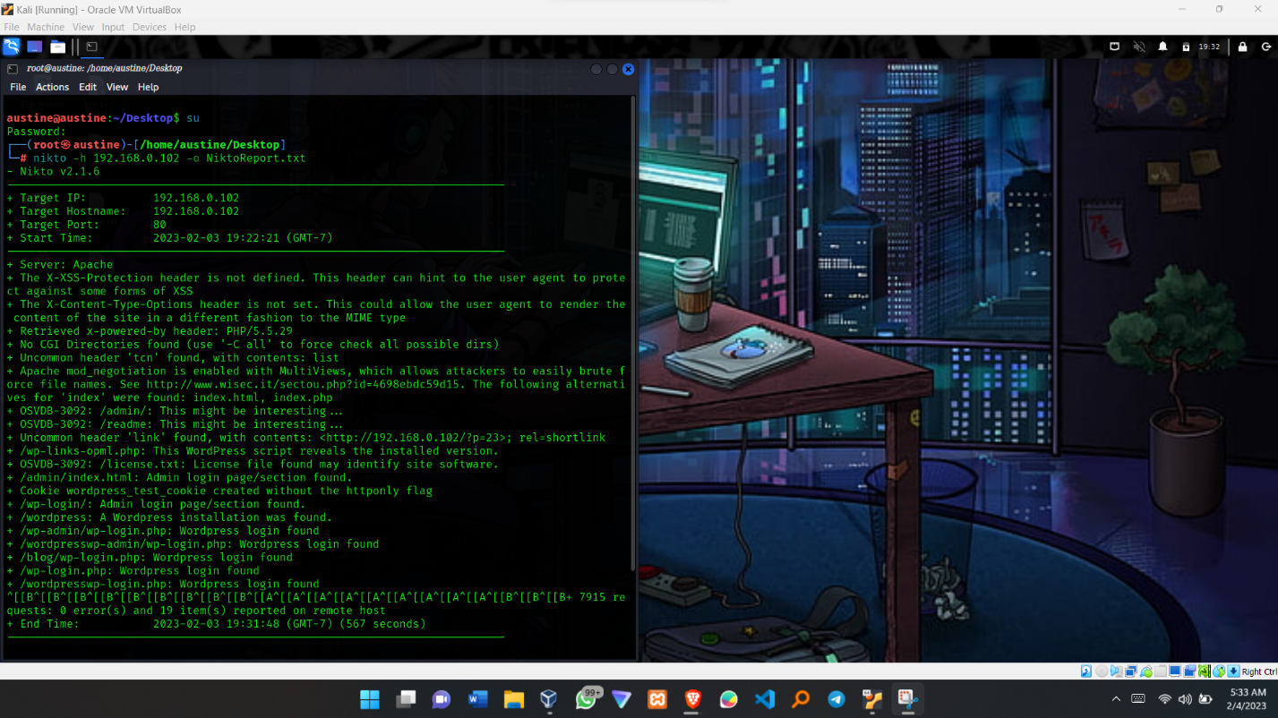

**Step 4:** Running wpscan, gather more information since the server is running on WordPress.

Command: **wpscan –-url 192.168.0.102 --passwords /root/fsocityEdited.dic –username Elliot**

**NB: THIS COMMAND WILL BE USED LATER IN FUTURE STEPS…. I WILL EXPLAIN IT FURTHER AS WE MOVE ON.**

**However**, from the wpscan we are able to see the path <http://192.168.0.102/robots.txt> exists

and we shall visit it to see what it holds for us.

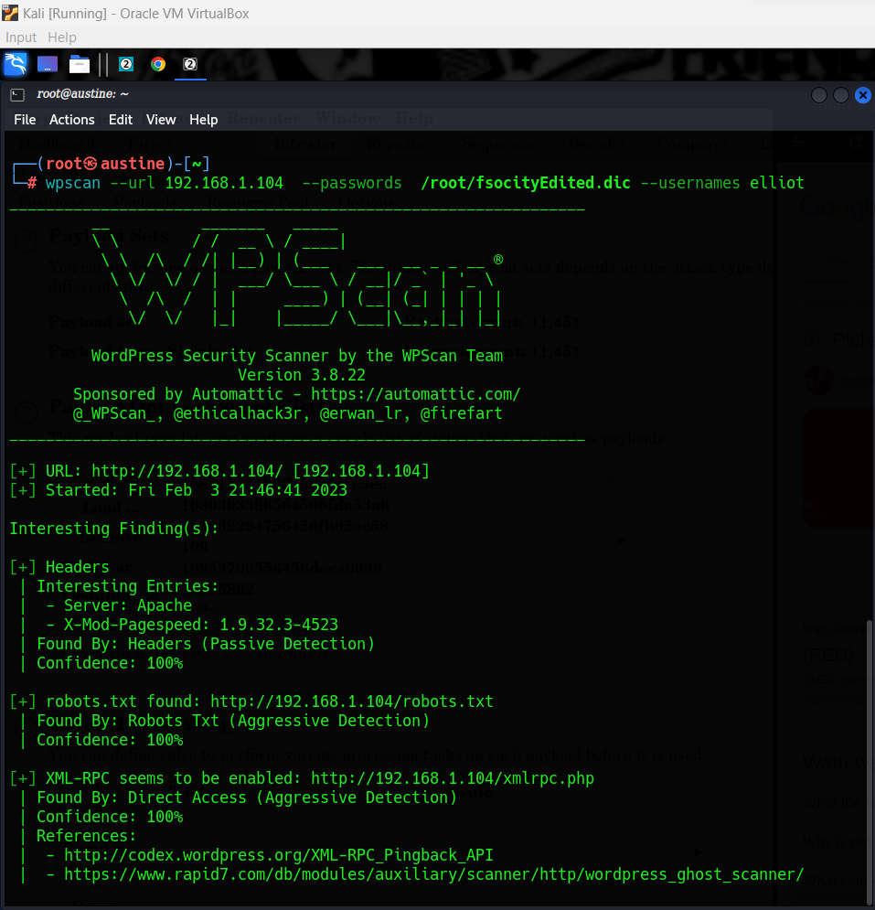

**Step 5:** Go to the path <http://192.168.0.102/robots.txt> where we see the results below.

1. Found the fsocity.dic (USED FOR BRUTE FORCE ATTACK LATER)
2. **First Key: key-1-of-3.txt**

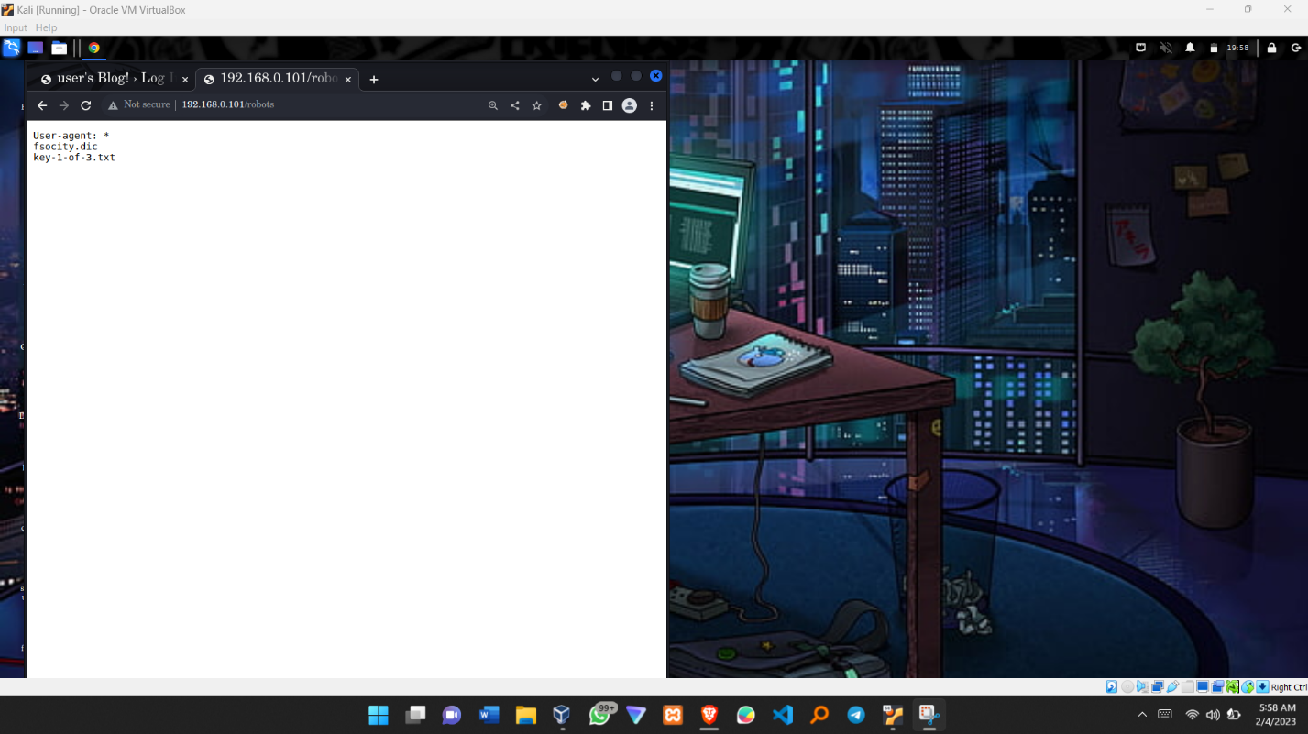

**Step 6:** Downloading the fsocity.dic and the “key-1-of-3.txt” using the wget commands.

Command : **wget** [**http://192.168.0.102/fsocity.dic**](http://192.168.0.102/fsocity.dic)

**Command : wget** [**http://192.168.0.102/key-1-of-3.txt**](http://192.168.0.102/key-1-of-3.txt)

**NB: TAKE NOTE OF THE DIRECTORY WHERE YOUR FILES HAVE BEEN DOWNLOADED.**

**\*\*\*\*\*\*\*\*\*\*\*\*\*\*\*\*\*\* HURRAY FIRST KEY FOUND ***********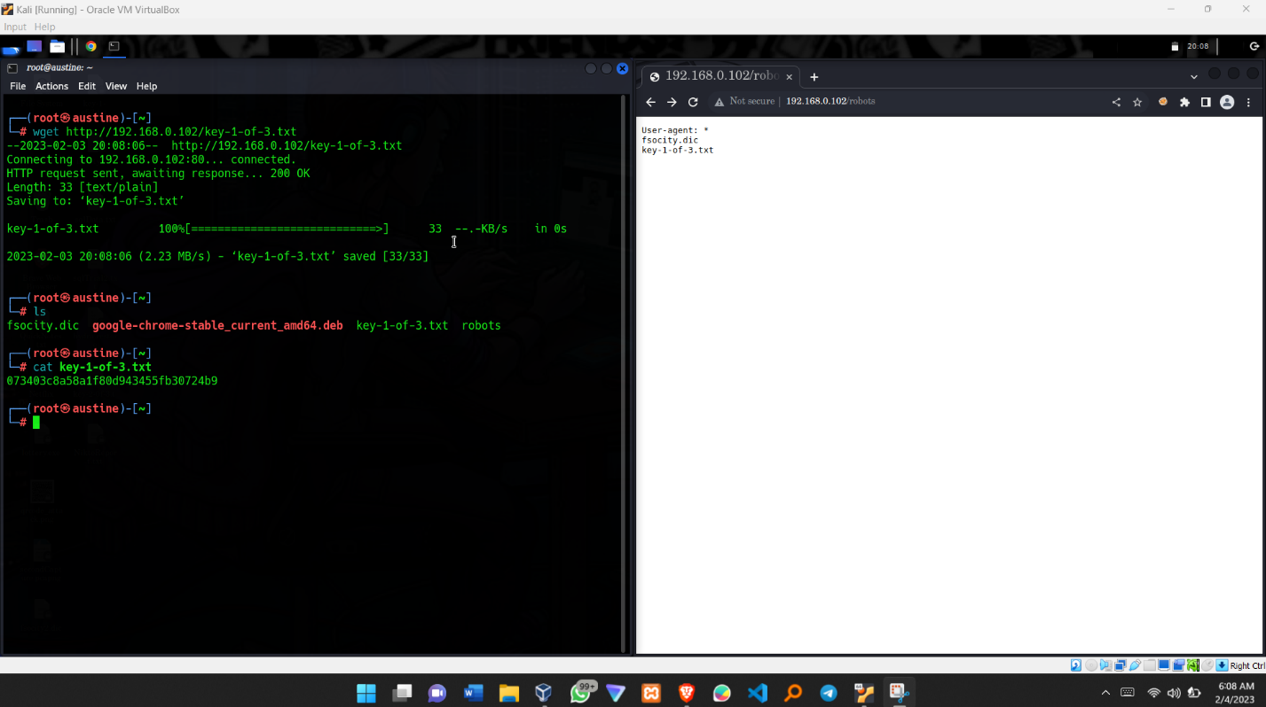**

**Step 7 :** Since the fsocity.dic provided has repeated words and numbers, we shall sort it out and also make sure that we make each word unique in the file.

Command: **cat fsocity.dic | sort | uniq > fsocityEdited.dic**

**Step 8:** Let us see how the login page looks like !!!!!

In the Browser, Navigate to url [**http://192.168.0.102/wp-login**](http://192.168.0.102/wp-login)

**APOLOGY: I failed to capture the screen shot for this page but am sure you will be able to see it if you navigate to the URL above**

**Step 9 :** The Tool Hydra comes into play. Hydra can be used for brute force attacks. And we will use our sorted out dictionaty ( fsocityEdited.dic ) **GOAL : Get the usernames**

Command : **hydra -V -L fsocityEdited.dic -p admin 192.168.0.102 http-post-form** **‘/wp-login.php : log=^USER^&pwd=^admin^&wp-submit=Log+In : F=Invalid Username ‘**

**Explanation :**

1. hydra : Trigger the hydra application
2. **-V :** Get the results in verbose formart.
3. -L : Specify the list to be used in the attack (fsocityEdited.dic)
4. -p : Specify the password to be used ( Can be anything. Not a must to be the correct password. The goal is to get the username for now !!!!)
5. admin : Our Dummy password used.
6. 192.168.0.102 : The ip address of the target machine.

**NB : THE REST OF THE COMMAND I USED BURP SUITE TO GET THE SYTRAX**

1. /wp-login.php : log=^USER^&pwd=^USER^&wp-submit=Log+In Extracted from Burp suite, **KINDLY TAKE TIME AND LEARN ABOUT SENDING REQUESTS AND RECEIVING RESPONSES FROM BURP SUITE**

**PICTORIAL DISPLAY**

**COMMAND**

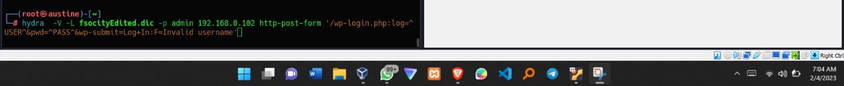

**RESULTS**

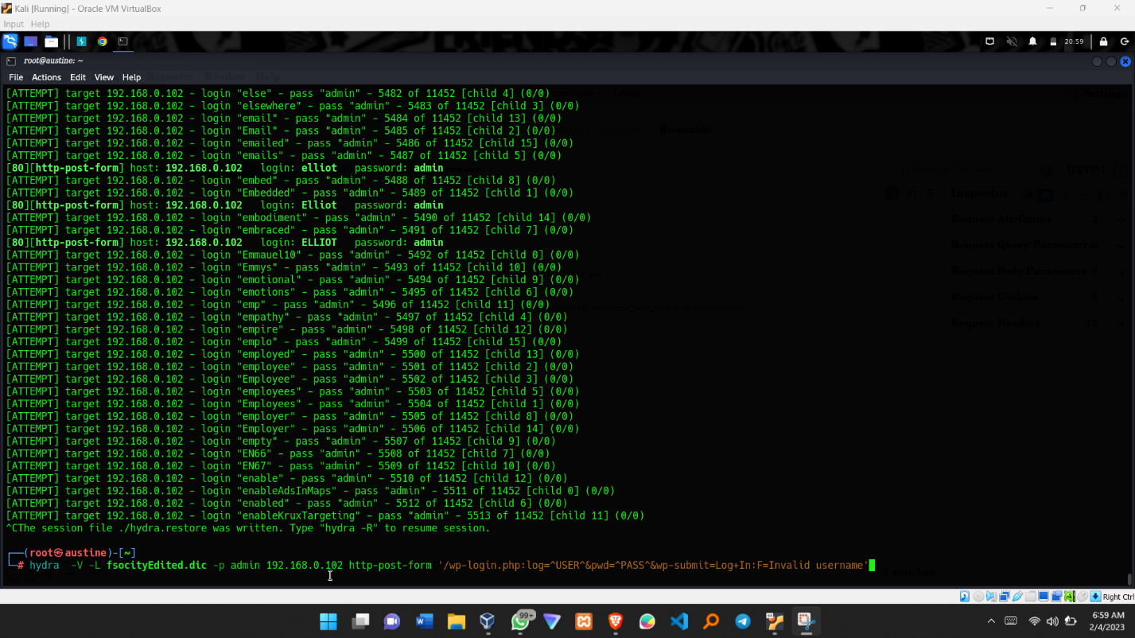

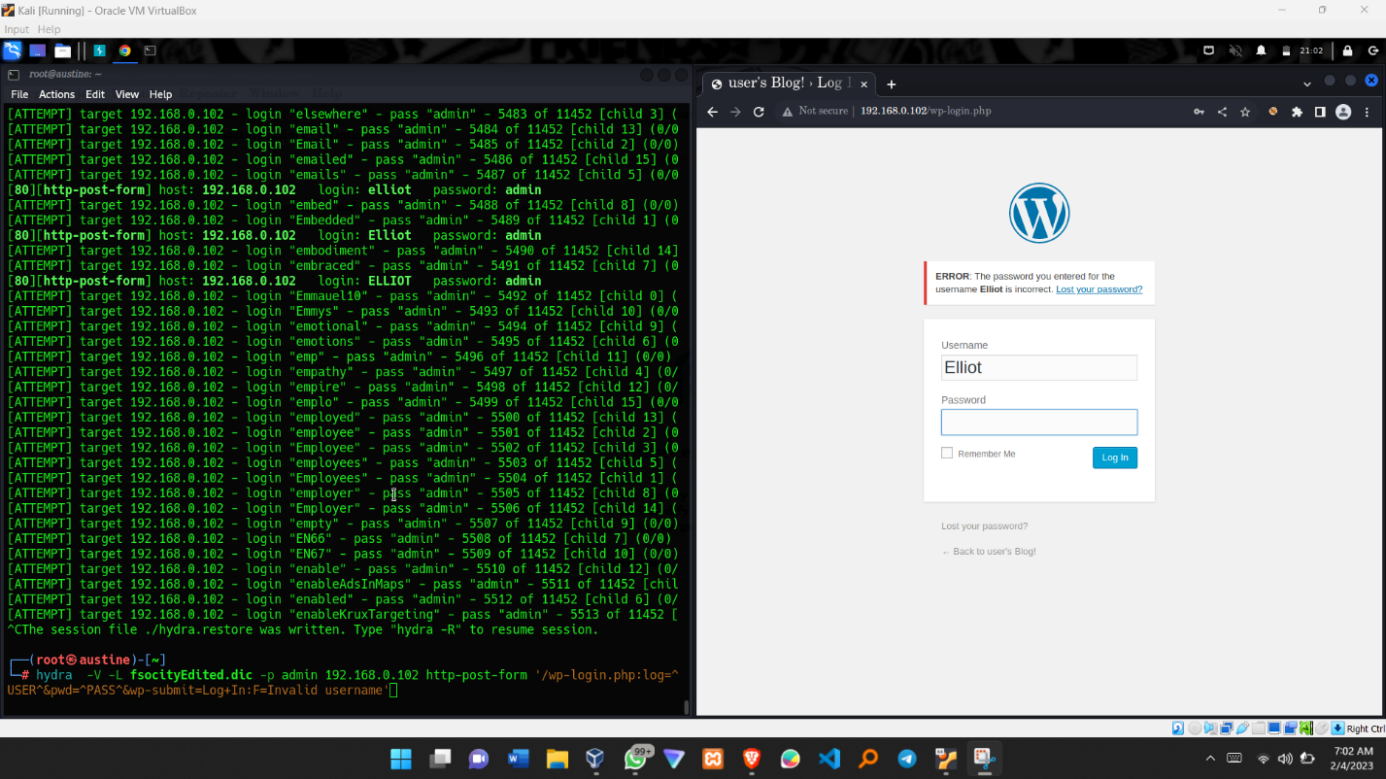

We now Know the Acceptable usernames to be used that is, **ELLIOT, Elliot and elliot**

**Step 10:** Getting the password for the given usernames, we shall use wpscan. The command used earlier.



Command: wpscan **–-url 192.168.1.104 --passwords /root/fsocityEdited.dic –username Elliot**

**Explanation**

1. **– url :** declare the url to be used
2. 192.168.1.104: **NB: NOTICE THE CHANGE IN IP ADDRESS, THIS IS BECAUSE I HAD TO CONFIGURE MY NETWORK SET UP FROM “INTERNAL NETWORK “TO “BRIDGED NETWORK “ IN THE VIRTUAL MACHINE SETUP.**

By doing so, the Ip addresses changed in both the kali Linux machine and the Vulnerable box. However, after this step you can return the network configuration back to Internal Network.

1. **--passwords** Declare the password ( if path available declare the path)
2. /root/fsocityEdited.dic : The path where the dictionary file to be used is stored.
3. –username : Declare the username to use. In our case Elliot
4. Elliot : The username to be used.

**RESULTS**

**Password: ER28-0652**

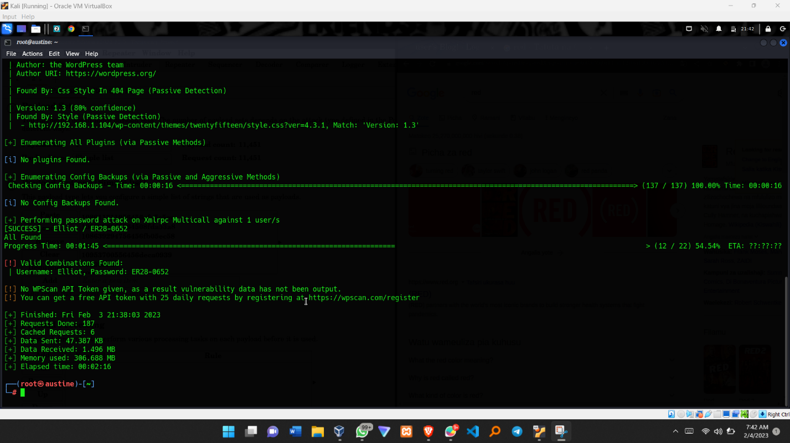

**Step 11: (Not a Must)** look for the password for the username Elliot and ELLIOT.

**Password: ER28-0652**

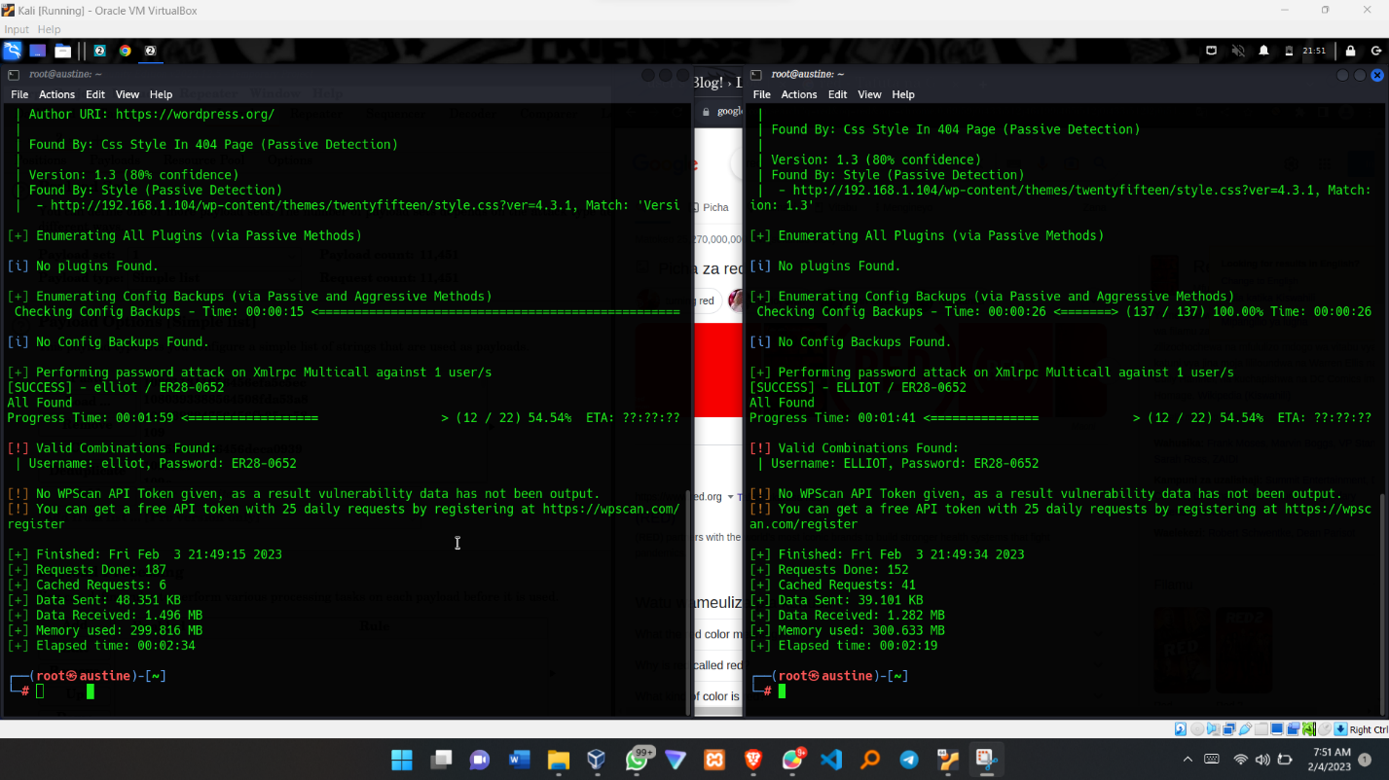

**Step 12 :** ENTER THE **USERNAME** AND **PASSWORD** AND WISH FOR THE BEST

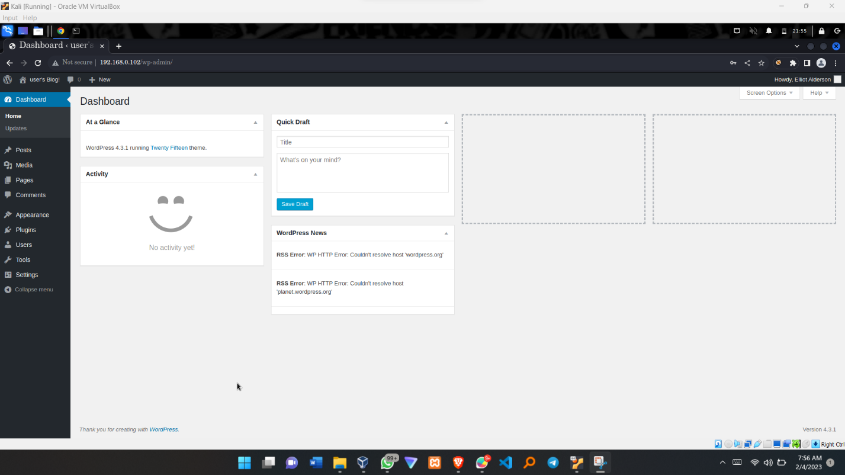

**\*\*\*\*\*\*\*\*\*\*\*\*\*\*\*\* HURRAY!!!!! SUCCESSFUL LOGIN \*\*\*\*\*\*\*\*\*\*\*\*\*\*\*\*\*\*\*\*\*\*\*\*\*\***

**Step 12:** Entering the Server through reverse shell. Using google, download a .php reverse shell into your computer. You can chose to use a bash or python package but in this demo I used a .php.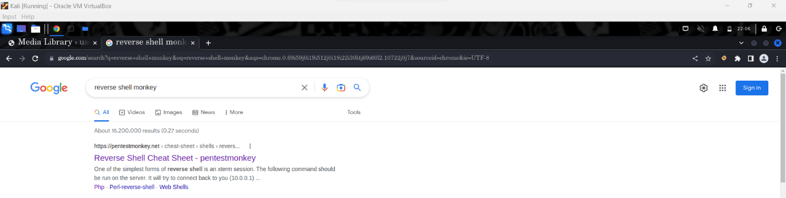

**Step 13**: Configure the reverse shell by changing the IP and the port number to be used. To do this, navigate to the directory where the file was downloaded and change the file with .php extension.

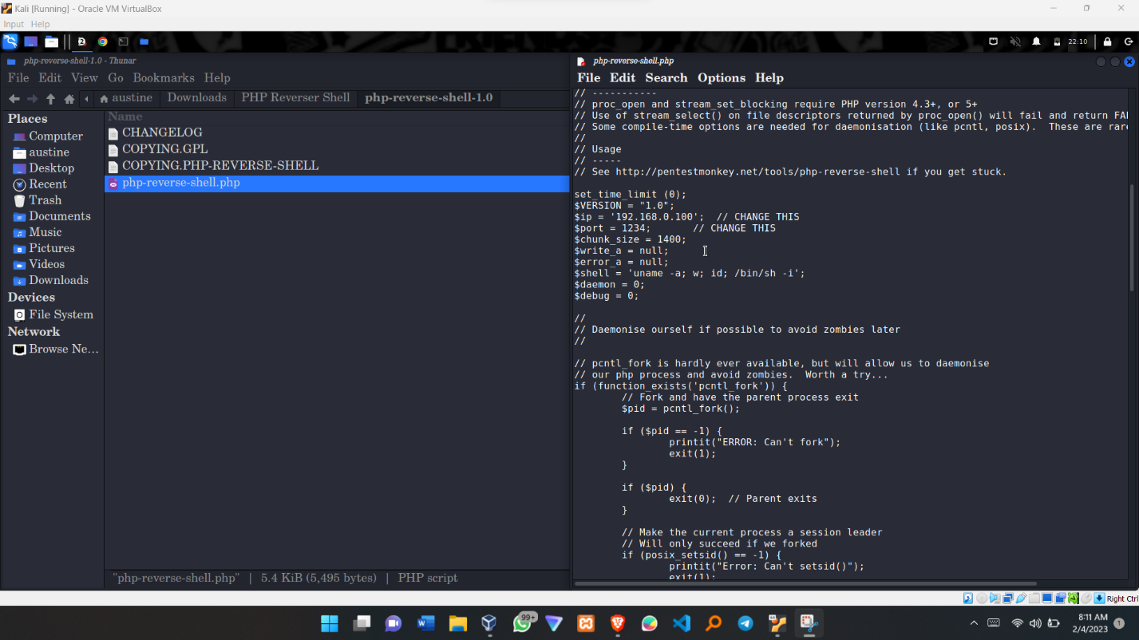

**Step 14 :** Copy the content found in php-reverse-shell.php you have just created (which has the modified Ip addresses). Since we already have the ability to log into the system look for any page that has a .php extension. In my case I used the 404.php Found in Apperances > Editors.

**NB : You can paste the content in any .php file of your choice.**

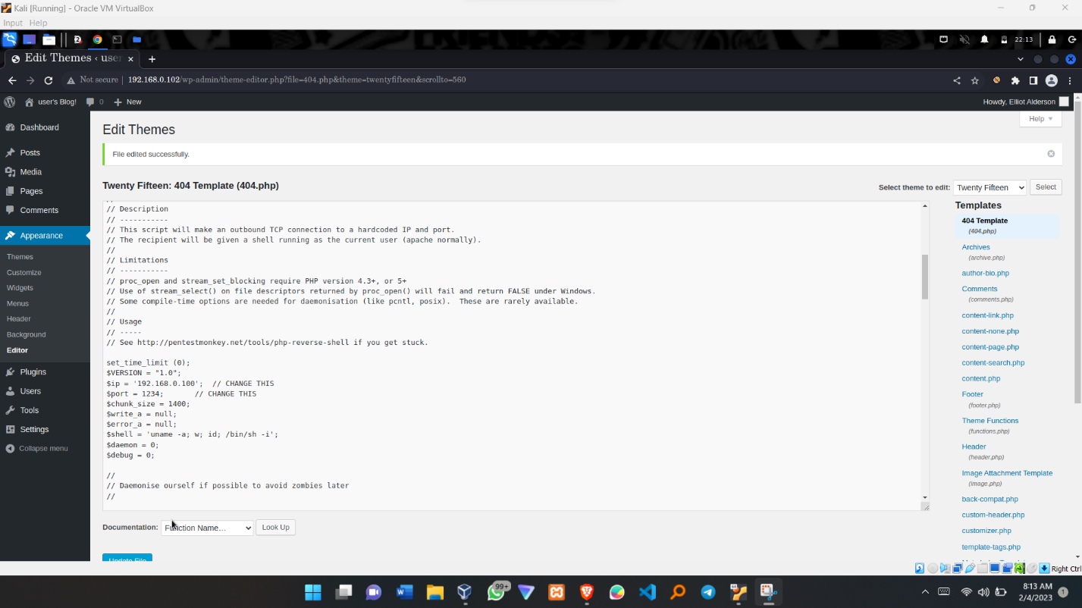

**Step 15:** Activate the **REVERSE SHELL PROGRAM**

1. Open two terminals
2. One, start netcat, Command: **nc -lvp 1234** //This starts a listener
3. Two, curl the webpage where you pluged in your reverse shell program. In my case, it will be Command: **curl** [**http://192.168..0.102/404.php**](http://192.168..0.102/404.php)

**IF SUCCESSFUL, WE WOULD HAVE LOGED INTO THE SHELL SYSTEM OF THE TARGET MACHINE.**



**Step 16:** Setting up configuration to be able to use the terminal

NB: You can cd into home and see the users available (**cd home**). The **ls** to see the users (**robot).** If we **ls** we find the **key-2-of-3.txt** and the **password.raw-md5** files.

However, If we try **“cat** **key-2-of-3.txt ”** command**,**  we don’t have permissions . Thus, we need to log in using the robot account.

Running Command : **su – robot** yields the error “ su : must be run from terminal ” the command below is used.

Use Command : **python -c ‘ import pty : pty.spawn(“/bin/sh”)’**

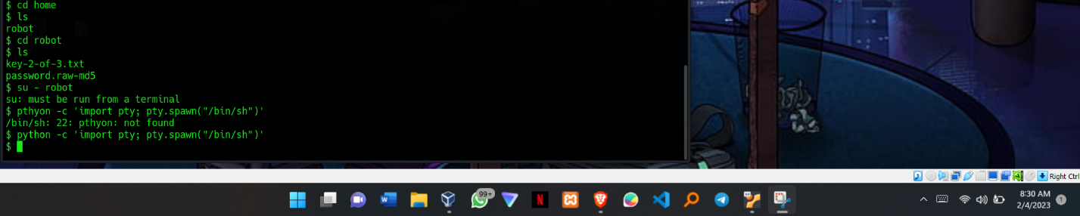

**Step 17:** Cracking the **md5** password for the **robot** account

The use of crackstation.net plays a crucial role here. We copy and paste the content of **password.raw-md5** from before and the results crack the hashed code

PASSWORD: **abcdefghijklmnopqrstuvwxyz**

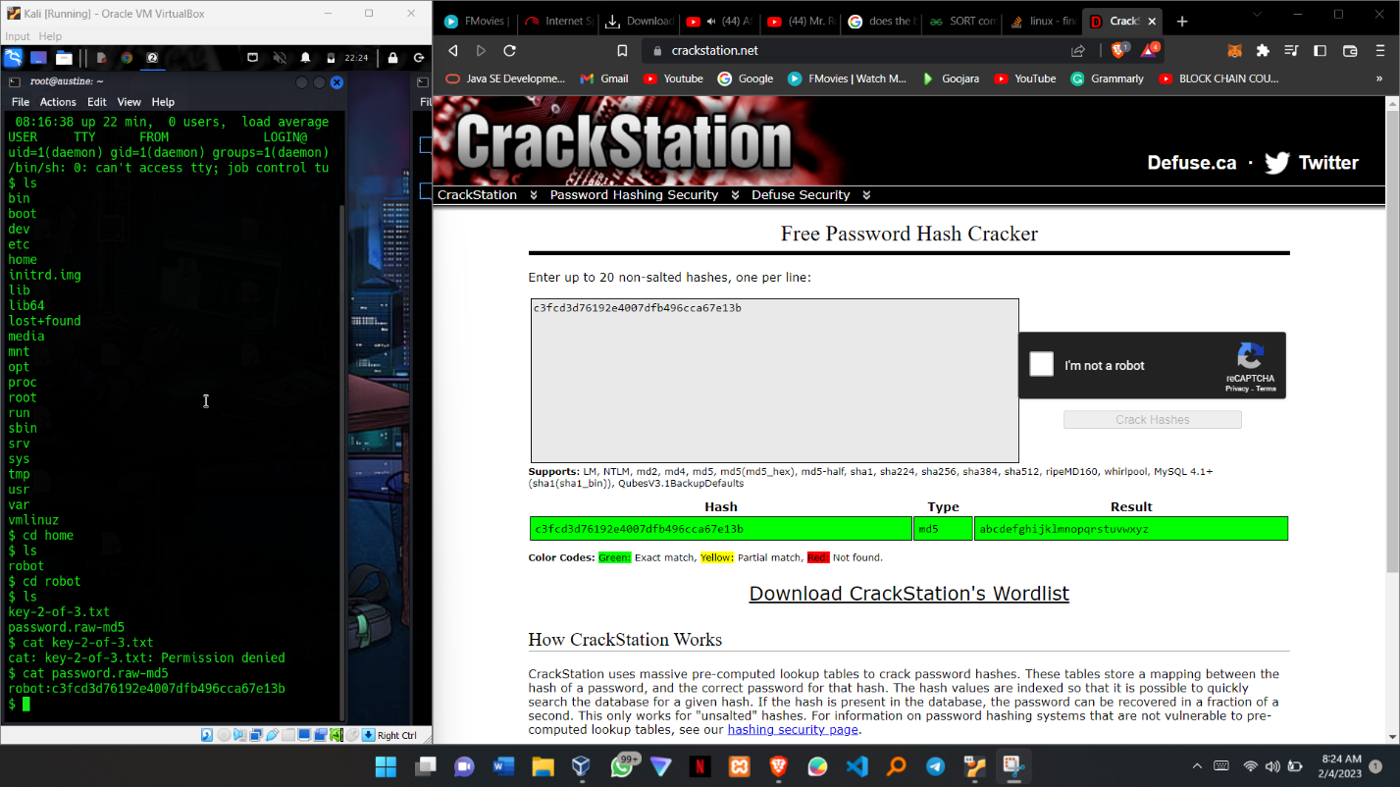

**Step 18 :** Acquiring key-2-of-3

Change user to robot using command : **su – robot**  and when asked for a password, enter **abcdefghijklmnopqrstuvwxyz** which we previously discovered**.**

Now we can access the second key and print out its output.

************ OOKKKKKKRRRRRR!!!!!! FOUND THE SECOND KEY *******

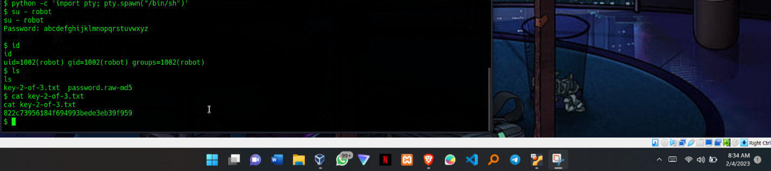

**Step 19:** Escalating Privileges to root.

We don’t have the permissions to log in as root but the use of Nmap --interactive will be very helpful. Additionally, we have to use the “ **!sh “** command to enable us enter shell commands while in the nmap interactive mode. That’s all!!

Finally, navigate through to root directory and you will be able to cat the third and final key

****************** IT’S A WRAPP!!!!!!!! ********************

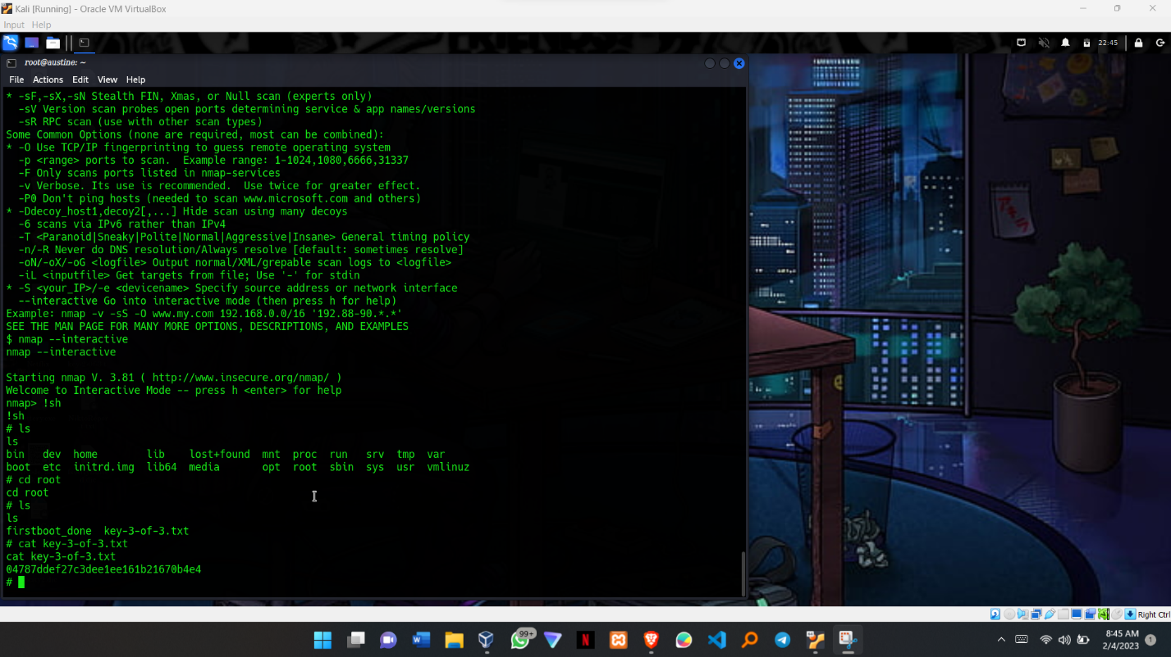

**Step 20: IF YOU FOUND THIS PRESENTATION HELPFUL KINDLY GIVE ME A FEEDBACK.**